# Ms Access - Recovery

1. 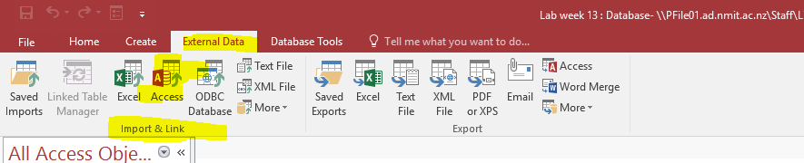On the External Data tab, in the Import and Link group, Click ACCESS.
2. 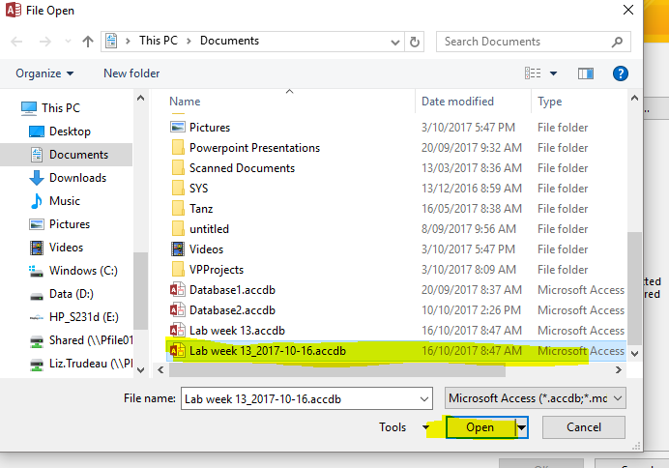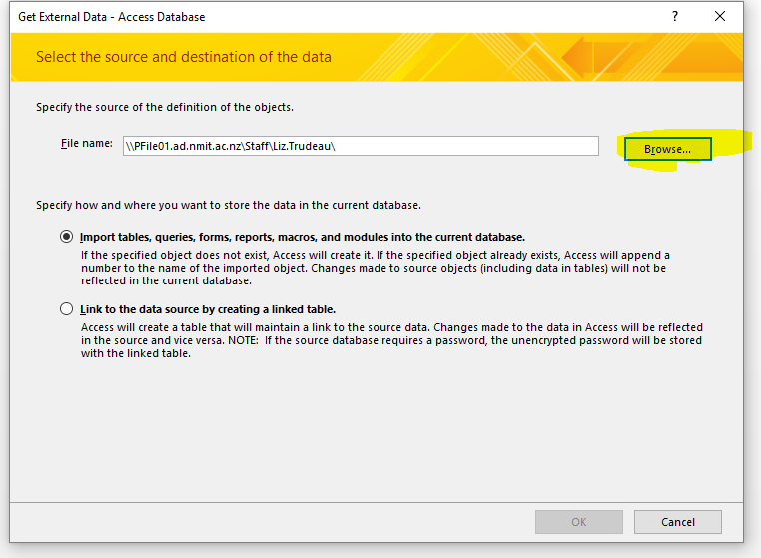In the get External Data - Access Database dialog box, click Browse to locate the backup database, and then click OPEN.
3. 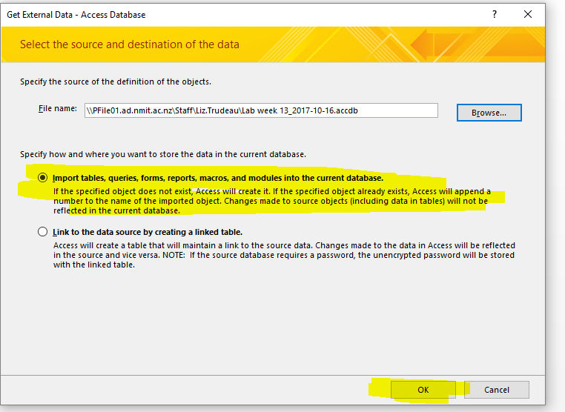Select "Import tables, queries, forms, reports, macros and modules" into the current database and then click OK
4. In the Import Objects dialog box, click the tab that corresponds to the type of object that you want to restore. EG. If you want to restore a table, click the Tables tab.

